**GitHub implementation in Android Projects**

1. Install the GITHUB application which is located in the path SAIKRUPA-PC\Users\Public\Downloads of our network and execute it .
2. Go to Local Disk of your computer users>username>Appdata(If the folder is not visible then make it visible)>Local>Github> Portablegit> cmd>

While giving the path add \git.exe at the end

Ex : C:\Users\Virinchi\AppData\Local\GitHub\PortableGit_d7effa1a4a322478cd29c826b52a0c118ad3db11\cmd\git.exe

1. In android studio project click on VCS ->Import into Version Control -> Create Git Repository and choose the project location and select the project hit on OK

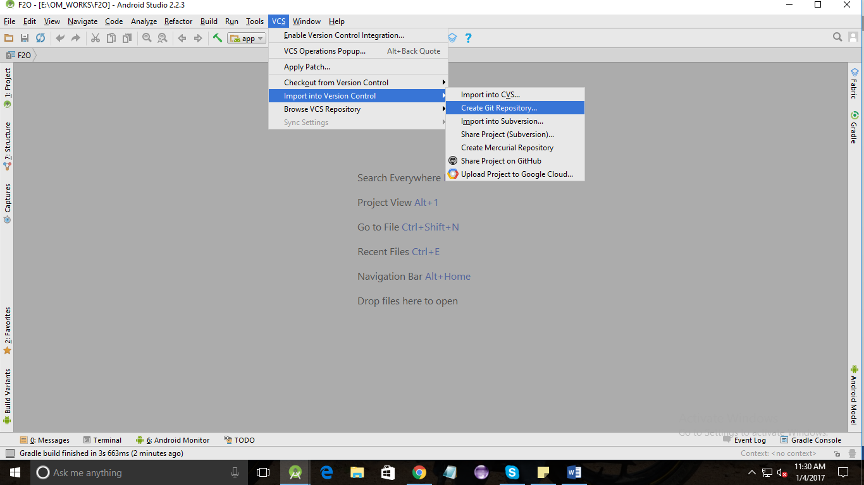

1. In the version control tab at the bottom move the unversioned files to default folder for moving file click on **browse** and right click on the folder you want to move and click on the add to vcs

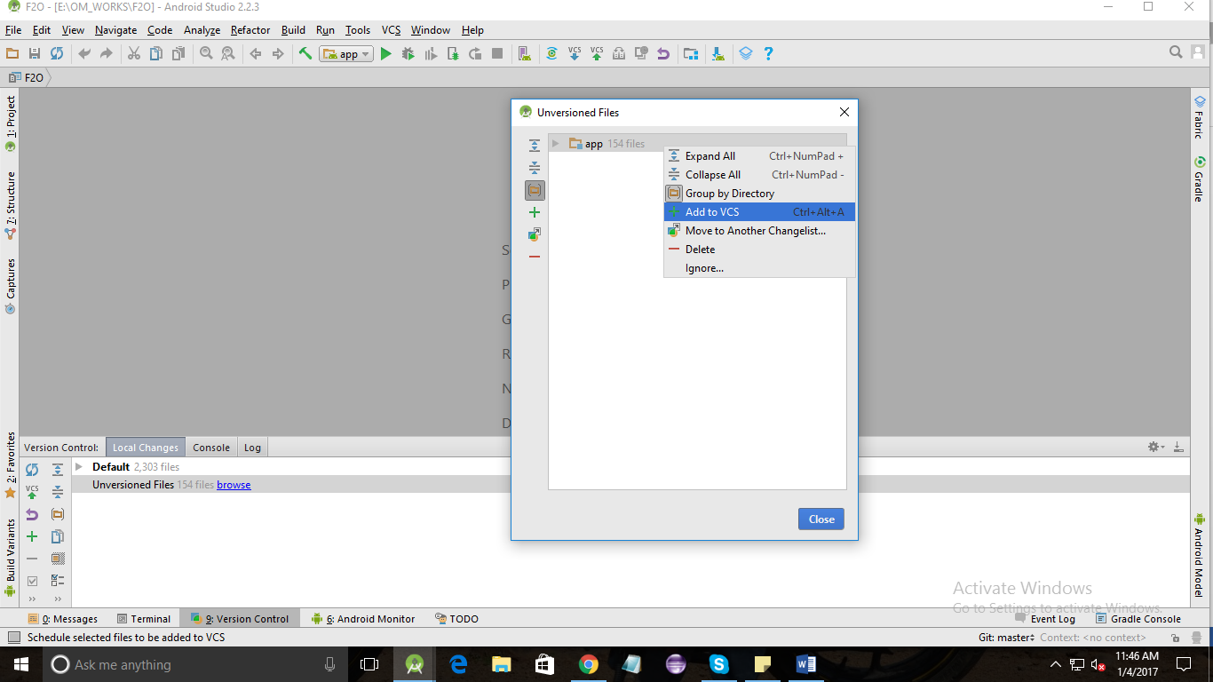

1. Click on **VCS (with up arrow)** which is locate in the toolbar and enter the commit message and click on commit after that your project is ready to upload to github
2. We need to add the project in GitHub account through web. Create your account if you don’t have, After the successful login click on **New Repository**and fill the details and choose your account type

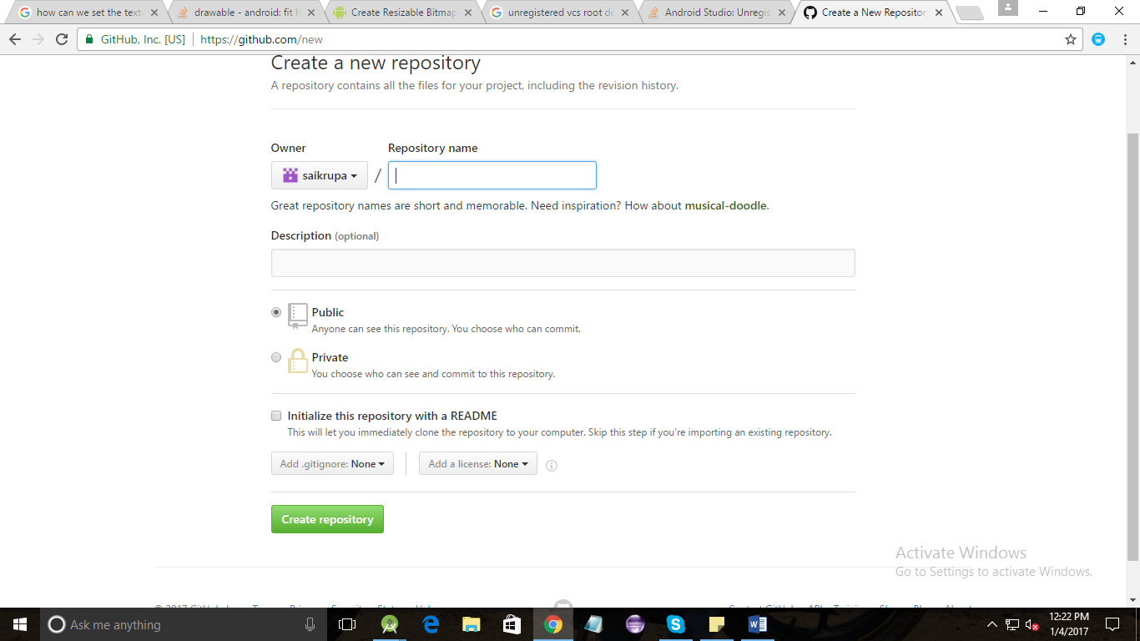

1. 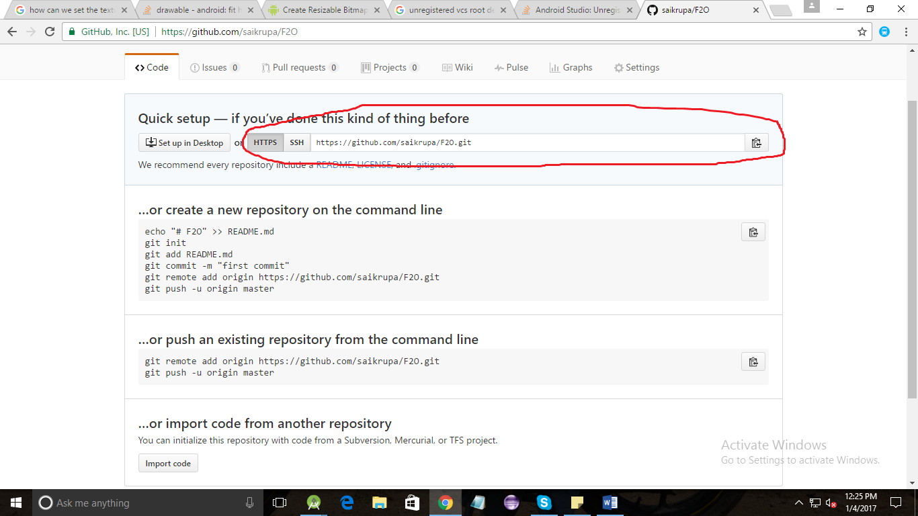After creating the repository you will get a link in the top of the page copy that link
2. Go to your android studio and click on VCS -> Git -> Push then you will get a below screen. Click on Define remote and give Name as “origin” and past the URL which is copied in step 5 and click OK. It will validate the URL if the URL is correct then you can ready to push your code to GitHub.

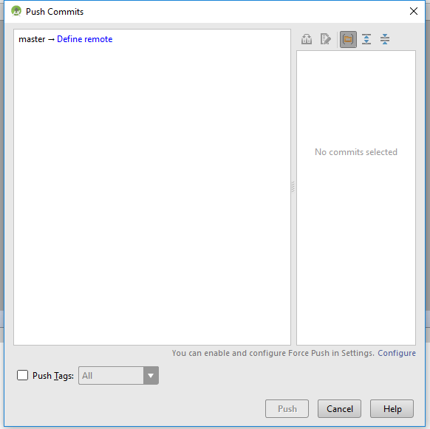

1. Once you hit the push button it will ask your GitHub password, enter your GitHub password to proceed.
2. After moving the project to Git if you do any changes in the code and you want to push that code to Git, hit on **VCS**with uparrowso that your changes will commit to Git.

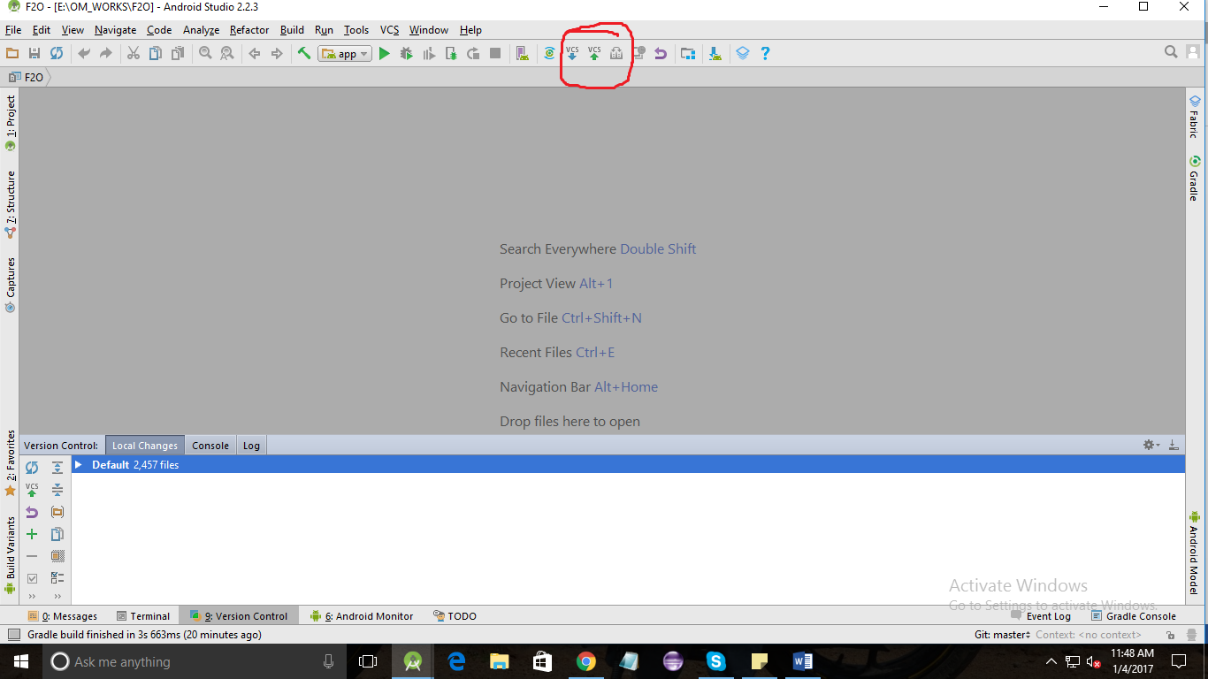

**Importing from Git:-**

1. If you want to import the project from Git click on File -> New -> Project from version control -> GitHub
2. Give the URL which is copied in Step 5 and locate the directory to store the project and click on clone then your project will be cloned to local system.
3. If you want to clone the changes which is committed by other developers in the toolbar click on the **VCS** with down arrow so that your project will be updated with the new changes